Germany finishes paying WWI reparations, ending century of 'guilt'
Few people in Germany noted the country's final $94 million WWI reparations payment on Sunday.
Some historians say that's for the best.
October 4, 2010
By Isabelle de Pommereau Correspondent
FRANKFURT

To some historians, World War I ended Sunday (Oct. 3, 2010).
Amid the news headlines marking the 20th anniversary of German reunification, the country quietly finished paying the last of its debt stemming from reparations imposed by the Versailles Peace Treaty more than 92 years ago.
"It's a symbol. It marks the end of World War I," says Ursula Rombeck-Jaschinski, a professor of modern history at Heinrich-Heine University in Düsseldorf. "It shows that Germany is prepared to pay back its debts after 92 years. More importantly, it also shows that Germany today is a totally different Germany than it was in the 1920s and 1930s."
Today Germany has a robust economy and is a model of financial stability, far from the heavily indebted nation that once ran up inflation and shrugged off creditors. While the last payment connected with the reparations passed virtually unnoticed here Sunday, for some Germans and many historians it marked the symbolic closing of a highly controversial treaty that ended one war and laid the foundation of another.
Seeds of Hitler’s rise
The so-called "guilt clause" of the 1919 Treaty of Versailles placed full blame for the war on Germany and ordered reparations of 132 billion German marks (roughly $400 billion in today's dollars). The debt fed a cycle of hyperinflation that pushed Germany to the brink of financial collapse.
By 1931, the international community had canceled Germany’s debts. By then the country had already paid 23 billion gold marks, or 17 percent of the Versailles demands, and still had to reimburse the foreign bonds it had issued in the 1920s to raise the reparation cash. The debt continued to fuel deep feelings of resentment, which Adolph Hitler exploited to catapult himself to power in 1934.
"Nothing played a greater role in Nazi propaganda than the refusal of Versailles and the promise to go back on the treaty," says Gerd Krumeich of the University of Düsseldorf, a World War I historian. "It gave rise to a campaign of propaganda and hatred."
"Without the Treaty of Versailles, the course of German history would have been quite different," agrees Carl-Ludwig Holtfrerich of Berlin’s Free University. "That was a lesson the Americans drew after World War II. They pleaded for a new world order where reparation was out of the question."
Paying, a step toward normalization
Following World War II, Germany was again looking for financial support in rebuilding a war-torn nation. As a way of reassuring investors, Chancellor Konrad Adenauer, in a breakthrough 1953 agreement in London, committed the newly created Federal Republic of Germany to resuming the pre-war debt leftover from Versailles.
"Germany wanted to prove to the world it was going to be an absolutely reliable creditor. It needed fresh cash, and it could only get fresh cash if it repaid its old debt," says Rombeck-Jaschinksi. "That was the basis for Germany’s ‘Wirtschaftswunder’ [economic miracle]. It was important for the reintegration of Germany into the Western world."
But Chancellor Adenauer also argued that the interest on foreign bonds stretching between 1949 and 1952 should be paid by the entire country – not only Western Germany – which meant those payments should only be paid after Germany was reunited.
By the early 1980s, the debt from the London agreement had been reduced and Germany had repaid its bonds. On Sunday, the German government paid foreign investors $94 million in the 20th and final installment of interest payments on those bonds, though a group of American investors have launched law suits, arguing that they are still owed money in connection with the bonds.
A new Germany
If the issue raised interest in the United States, France, and England, it barely made headlines in Germany. Apart from history buffs, few here today even know about the Versailles Treaty.
And maybe that's for the best, says Professor Holtfrerich.
"The issue of reparation was so hot politically between the two wars that I think one should keep those old wounds closed, especially in the sake of Franco-German relations," he says. "The lesson drawn was the creation of a unified Europe after World World I that should prevent any other war. I think that the lesson has been drawn."
Rombeck-Jaschinks says that the Versailles Treaty was signed too long ago for most people to remember. But perhaps, she adds, the last "guilt clause" payment can serve as a reminder to Germans of how far their country has come over the past century.
"It’s important for our normalization," she says. "We know that after reunification, we have our full sovereignty. Step by step, we became a state accepted by our neighbors, a democratic state."
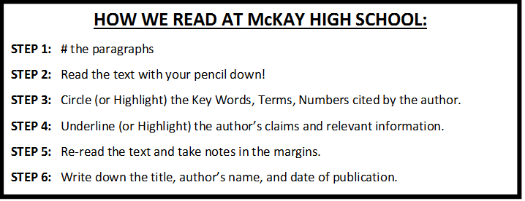

Essential Question: “Can Peace Lead to War?”
Your Task:
- READ the Christian Science Monitor article “Germany Finishes Paying WWI Reparations, Ending Century of 'Guilt',” using the “How We Read at McKay High School” strategies above.
- DISCUSS with an elbow partner why some historians claim World War I did not end until 2010. Both of you write down your answers on your Versailles Treaty Cornell Notes page.

