PRIMARY SOURCE: Woodrow Wilson, speech to the United States Senate describing his approach to ending World War I, “Peace without Victory” (excerpts), January 22, 1917
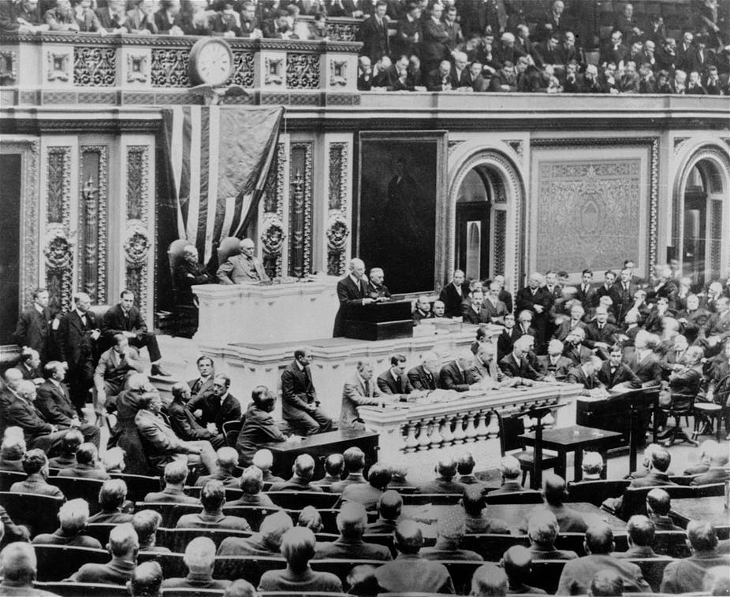
Gentlemen of the Senate,
On the 18th of December last I addressed an identic note to the governments of the nations now at war requesting them to state, more definitely than they had yet been stated by either group of belligerents, the terms upon which they would deem it possible to make peace. I spoke on behalf of humanity and of the rights of all neutral nations like our own, many of whose most vital interests the war puts in constant jeopardy. The Central powers united in a reply which stated merely that they were ready to meet their antagonists in conference to discuss terms of peace. The Entente powers have replied much more definitely and have stated, in general terms, indeed, but with sufficient definiteness to imply details, the arrangements, guarantees, and acts of reparation which they deem to be the indispensable conditions of a satisfactory settlement. We are that much nearer a definite discussion of the peace which shall end the present war. We are that much nearer the discussion of the international concert which must thereafter hold the world at peace. In every discussion of the peace that must end this war it is taken for granted that that peace must be followed by some definite concert of power which will make it virtually impossible that any such catastrophe should ever overwhelm us again. Every lover of mankind, every sane and thoughtful man, must take that for granted.…

The present war must first be ended; but we owe it to candor and to a just regard for the opinion of mankind to say that, so far as our participation in guarantees of future peace is concerned, it makes a great deal of difference in what way and upon what terms it is ended. The treaties and agreements which bring it to an end must embody terms which will create a peace that is worth guaranteeing and preserving, a peace that will win the approval of mankind, not merely a peace that will serve the several interests and immediate aims of the nations engaged. We shall have no voice in determining what those terms shall be, but we shall, I feel sure, have a voice in determining whether they shall be made lasting or not by the guarantees of a universal covenant; and our judgment upon what is fundamental and essential as a condition precedent to permanency should be spoken now, not afterwards when it may be too late.…

The terms of the immediate peace agreed upon will determine whether it is a peace for which such a guarantee can be secured. The question upon which the whole future peace and policy of the world depends is this: Is the present war a struggle for a just and secure peace, or only for a new balance of power? If it be only a struggle for a new balance of power, who will guarantee, who can guarantee, the stable equilibrium of the new arrangement? Only a tranquil Europe can be a stable Europe. There must be, not a balance of power, but a community of power; not organized rivalries, but an organized common peace.
Fortunately we have received very explicit assurances on this point; the statesmen of both of the groups of nations now arrayed against one another have said, in terms that could not be misinterpreted, that it was no part of the purpose they had in mind to crush their antagonists. But the implications of these assurances may not be equally clear to all—may not be the same on both sides of the water. I think it will be serviceable if I attempt to set forth what we understand them to be.
They imply, first of all, that it must be a peace without victory. It is not pleasant to say this. I beg that I may be permitted to put my own interpretation upon it and that it may be understood that no other interpretation was in my thought. I am seeking only to face realities and to face them without soft concealments. Victory would mean peace forced upon the loser, a victor's terms imposed upon the vanquished. It would be accepted in humiliation, under duress, at an intolerable sacrifice, and would leave a sting, a resentment, a bitter memory upon which terms of peace would rest, not permanently, but only as upon quicksand. Only a peace between equals can last, only a peace the very principle of which is equality and a common participation in a common benefit. The right state of mind, the right feeling between nations, is as necessary for a lasting peace as is the just settlement of vexed questions of territory or of racial and national allegiance.
The equality of nations upon which peace must be founded if it is to last must be an equality of rights; the guarantees exchanged must neither recognize nor imply a difference between big nations and small, between those that are powerful and those that are weak. Right must be based upon the common strength, not upon the individual strength, of the nations upon whose concert peace will depend. Equality of territory or of resources there of course cannot be; nor any other sort of equality not gained in the ordinary peaceful and legitimate development of the peoples themselves. But no one asks or expects anything more than an equality of rights. Mankind is looking now for freedom of life, not for equipoises of power.…

And there is a deeper thing involved than even equality of right among organized nations. No peace can last, or ought to last, which does not recognize and accept the principle that governments derive all their just powers from the consent of the governed, and that no right anywhere exists to hand peoples about from sovereignty to sovereignty as if they were property. I take it for granted, for instance, if I may venture upon a single example, that statesmen everywhere are agreed that there should be a united, independent, and autonomous Poland, and that henceforth inviolable security of life, of worship, and of industrial and social development should be guaranteed to all peoples who have lived hitherto under the power of governments devoted to a faith and purpose hostile to their own.…

I am proposing, as it were, that the nations should with one accord adopt the doctrine of President Monroe as the doctrine of the world: that no nation should seek to extend its polity over any other nation or people, but that every people should be left free to determine its own polity, its own way of development, unhindered, unthreatened, unafraid, the little along with the great and powerful.
I am proposing that all nations henceforth avoid entangling alliances which would draw them into competitions of power, catch them in a net of intrigue and selfish rivalry, and disturb their own affairs with influences intruded from without. There is no entangling alliance in a concert of power. When all unite to act in the same sense and with the same purpose, all act in the common interest and are free to live their own lives under a common protection.
I am proposing government by the consent of the governed; that freedom of the seas which in international conference after conference representatives of the United States have urged with the eloquence of those who are the convinced disciples of liberty; and that moderation of armaments which makes of armies and navies a power for order merely, not an instrument of aggression or selfish violence.
These are American principles, American policies. We could stand for no others. And they are also the principles and policies of forward-looking men and women everywhere, of every modern nation, of every enlightened community. They are the principles of mankind and must prevail.

Public domain. The full speech is available on the PBS website: http://www.pbs.org/wgbh/amex/wilson/filmmore/fm_victory.html.

