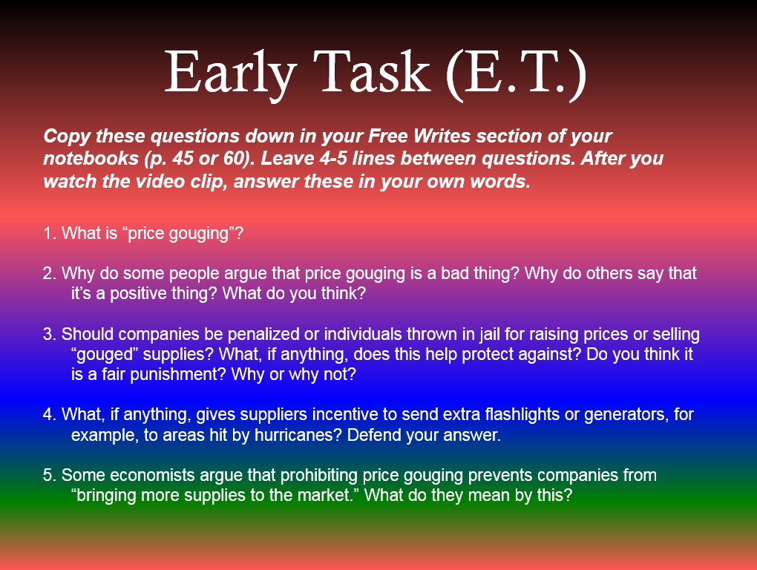
Video: “Is Price Gouging Bad?”

