UNSTOPPABLE - Anthony Robles' Story

Of Determination
By Jim Bates, Winnerswin.com
11, Nov 2013
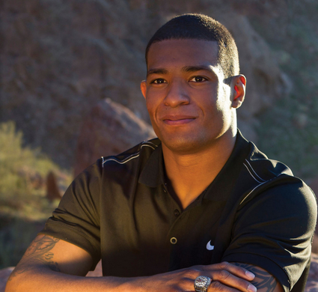
Being the smallest kid on your freshman high school wrestling team has to be pretty intimidating in and of itself but just imagine being “that guy” and having only one leg. This is the story of the unstoppable Anthony Robles and yes, Anthony was and is “that guy”.
The early years –
It was 1998 and 16 year old Judy Robles was lying in the maternity ward in a hospital just outside Phoenix, about to give birth to her first child. As Anthony was making his way into the world it was apparent that something wasn’t quite right. “He’s missing his leg” said her father, who was in the delivery room with her at the time.
At first Judy cried but as she lied there holding him she thought to herself “to me, he is perfect”. That turned out to be a defining one in her young life. With seemingly no thought, she quickly adopted a winning attitude… one that she would instill in her new son and one that would undoubtedly help him to become a champion not only on the wrestling mat, but in all facets of his life.
Throughout his childhood, Anthony had to go through all of the typical trials children have to deal with when growing up. However, having only one leg, there was a lot more on his plate than what most of us have to worry about. Simple things we all take for granted, like putting our clothes on or getting ready for and making it to school, were daily struggles for Anthony. Beyond that, there were always the stares, the situations that would create doubt.
At the early age of 3, he made the decision that his disability was not going to control his life. Perhaps in a show of defiance, he took off his prosthetic leg and hid it from his mother so he wouldn’t have to wear it. Even then, Anthony was showing signs that he was, in fact, going to be unstoppable.
He wanted to be just like everybody else and from that day he owned the belief that there was nothing he wasn’t going to be able to do. His little brother Nicolas recalls… “He would play basketball and football with us. He only had one leg but I always wanted him on my team because he was one of the best”.
Time for high school –
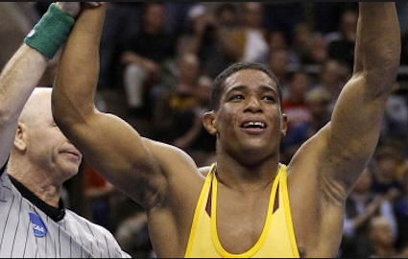
Anthony’s first wrestling match during his freshman year definitely didn’t prove anything to the world about what a good wrestler he was but it did make a very clear statement to all who witnessed as to what kind of heart he had. As was customary for the team, they ran out into the gymnasium and circled the mat. Anthony was right there with them, hopping on one leg… unstoppable.
The rest of that first season wasn’t a lot better for Anthony. He continued to get beat far more often than he won. At some point Anthony latched on to Chris Freije, one of Anthony’s high school teammates. Chris was one of the better wrestlers on the team and Anthony would show up wherever Chris was, even challenging him to take him on. As was the code on the team, Chris obliged Anthony and of course dominated him every time.
What started out with Anthony being little more than a pest to Chris at some point turned into a relationship of the two becoming best friends. Kalani Simpson of ESPN likened it to the Rocky – Apollo Creed relationship… rightly so.
It was through this relationship that Anthony really began to come into his own as a wrestler. He had finally made a believer of his teammates and his coaches with his dedication, commitment and “unstoppable” attitude. His coaches started to focus on strategies and techniques Anthony could use to his advantage that fit his body type. By his junior year, Anthony had become the guy everyone wanted to work and train with. In his last two years of high school Anthony would win two state wrestling championships and his senior year was a national champion in his weight class. His high school record is a very impressive 129-15… 48-0 in his last two seasons.

Unstoppable Anthony… the record breaker –
Unstoppable Anthony stayed loyal to his roots and went to college right down the street from his house at Arizona State University. He went on to become one of the most accomplished wresters in Sun Devil history. His accomplishments are so numerous I’m going to bullet point them here to make it easier to read!
The List:
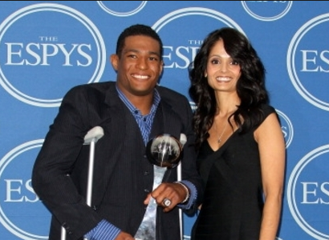
· 2011 NCAA Champion
· 2011 NCWA Outstanding Wrestler of the Tournament
· Four-time NCAA All-American
· Four-time NCAA Qualifier
· Three-time PAC 10 Conference Champion
· Four-time PAC 10 Conference Finalist
· Finished 8th in career victories at 122
· Finished his 2011 season at ASU with a perfect 36-0 season
Anthony’s list of accomplishments, awards and accolades is very long. The short list above is merely a highlight of his record at ASU. Anthony is now involved with inspiring young athletes to reach for their dreams and can be booked to speak at events. He was also inducted into the National Wrestling Hall Of Fame in 2012.
There is no question that Anthony Robles personifies everything that is meant by being a Winner. Through his hard work, dedication and belief in self, he became everything he knew he was that day he hid his prosthetic leg from his mother… UNSTOPPABLE.
“Unstoppable” by Anthony Robles
Every soul who comes to earth
With a leg or two at birth
Must wrestle his opponents knowing
It’s not what is, it’s what can be, that measures worth
Make it hard, just make it possible
And through pain. I’ll not complain,
My spirit is unconquerable
Fearless I will face each foe
For I know I am capable,
I don’t care what’s probable
Through blood, sweat and tears,
I am Unstoppable!

