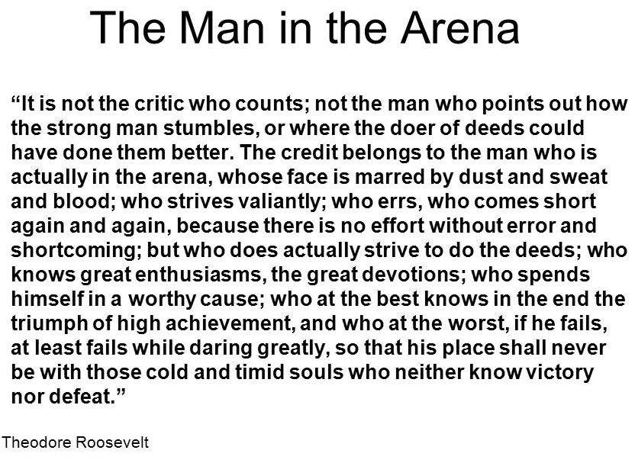

COMPLETE THE FOLLOWING IN YOUR “ACTIVITIES SECTION”
- READ this entire quote with your pencil down.
- REREAD the quote and UNDERLINE the 3 words that are most descriptive.
- HIGHLIGHT the 2 sentences or phrases that most describe Leadership.
- SUMMARIZE this quote in one sentence, using your own words
- WRITE 1-2 paragraphs in response to this prompt:
“How can you apply “The Man in the Arena” quote to your role as a team leader?”

